

**MEENAKSHI SUNDARARAJAN ENGINEERING COLLEGE**

Kodambakkam, Chennai-600024.

# **DATA ANALYTICS**

## DEPARTMENT OF INFORMATION TECHNOLOGY

### TOPIC: Data Titans: Unearthing Trends from Linked in Influencers

TEAM ID: F0D5C3415502FE8A788464F188059430

FACULTY MENTOR: Nandhakumari INDUSTRY MENTOR: Shivam Shivhare

Project submitted by,

|  |  |  |
| --- | --- | --- |
| **TEAM** | **NAME** | **REG. NO.** |
| Team Leader | Gopinath.J | 311520205012 |
| Teammate 2 | Pavithira.E | 311520205031 |
| Teammate 3 | Aathif Ahmed.Z | 311520205002 |
| Teammate 4 | Rajesh.R | 311520205034 |

**ABSTRACT:**

In the age of digital influence, staying ahead of industry trends and understanding the evolving landscape of professional discourse is crucial for individuals and organizations. LinkedIn, as a prominent platform for networking and knowledge sharing, is home to a vast community of influencers whose insights and discussions often mirror the pulse of industries and sectors. Unearthing trends from LinkedIn influencers entails the systematic extraction and analysis of data from these thought leaders, providing valuable insights for various stakeholders. This abstract outlines a multifaceted approach to unearthing trends from LinkedIn influencers. It involves the collection and analysis of social media data generated by these influencers, the identification of trending topics, and the provision of insights to diverse user roles such as marketing managers, content creators, data analysts, and business owners. The system also supports the scheduling of content, sentiment analysis, and trend visualization, catering to a wide array of needs. In addition, it enables researchers and journalists to connect with influencers for expert opinions and interviews.Through the amalgamation of cutting-edge technologies, trend analysis, and social listening, unearthing trends from LinkedIn influencers empowers individuals and organizations to adapt, innovate, and make data-driven decisions in an ever-evolving professional landscape. This abstract serves as an introduction to the user stories, data flow diagrams, and flowcharts that depict the dynamic process of trend discovery on LinkedIn, ultimately enhancing the ability to harness knowledge from thought leaders in the digital age.

**ProjectReportFormat**

## INTRODUCTION

* 1. Project Overview
  2. Purpose

## LITERATURESURVEY

* 1. Existing problem
  2. References
  3. Problem Statement Definition

## IDEATION&PROPOSEDSOLUTION

* 1. Empathy Map Canvas
  2. Ideation & Brainstorming
  3. Proposed Solution
  4. Problem Solution fit

## REQUIREMENTANALYSIS

* 1. Functional requirement
  2. Non-Functional requirements

## PROJECT DESIGN

* 1. Data Flow Diagrams
  2. Solution&TechnicalArchitecture
  3. User Stories

## PROJECT PLANNING & SCHEDULING

* 1. User Stories

### CODING&SOLUTION(Explain thefeaturesaddedin theprojectalongwith code)

* 1. Feature 1
  2. Output

## TESTING

* 1. TestCases

## RESULTS

* 1. Performance Metrics

1. **ADVANTAGES&DISADVANTAGES**
2. **CONCLUSION**
3. **FUTURE SCOPE**
4. **APPENDIX**

GitHub & Project Demo Link

## INTRODUCTION

In today's fast-paced, information-rich digital landscape, staying attuned to emerging trends is vital for individuals and organizations looking to thrive and innovate. LinkedIn, the world's largest professional networking platform, has emerged as a veritable hub for knowledge sharing and trendsetting, with influential voices shaping discussions across various industries. The process of unearthing trends from LinkedIn influencers represents a strategic endeavor to tap into this valuable wellspring of information. LinkedIn, a platform with more than 800 million members worldwide, serves as a breeding ground for experts, thought leaders, and industry professionals who engage in meaningful conversations and share their insights on a broad range of subjects. These influencers, known for their expertise, experiences, and large networks, possess the power to catalyze trends and shape the discourse within their respective niches. As such, discerning and understanding the themes and topics they champion is not just beneficial but often critical for anyone looking to remain competitive in their field.

**PROJECT OVERVIEW**

The process of unearthing trends from LinkedIn influencers involves a multifaceted approach, encompassing data collection, analysis, and dissemination. It is a convergence of technology, data science, and social listening, allowing individuals and organizations to extract valuable insights and transform them into informed decisions. Whether you're a marketing manager seeking to tailor your strategies, a content creator in search of inspiration, or a data analyst looking for patterns, the ability to harness the collective wisdom of LinkedIn influencers is an invaluable asset.

## PROJECT FLOW

### ProjectInitiation

* 1. Define the scope and objectives of the analysis.
  2. Establish the timeline and allocate resources for the project.
  3. Formulate the research questions and key areas of focus.

### Data Collection and Research

* 1. Gather relevant data from various sources, including industry reports, marketresearch, and academic studies.
  2. Collect data on Linkedin platforms, their features, business models, andmarket performance.
  3. Conduct interviews or surveys with industry experts,influencers, and suppliers togather qualitative insights.

### Market Overview

* 1. Analyze the current state of the Linkedin market.
  2. Identify and evaluate major players in socialmedia.
  3. Assess market share, growth trends, and regional variations.
  4. Examine factors influencing the competitive market.

### Business Models and Operations

* 1. Explore the underlying business models of Linkedin users.
  2. Analyze revenue generation strategies and profitability.
  3. Investigate partnership models with suppliers, including social media managers, stakeholders, content creators etc
  4. Examine customer acquisition and retention strategies.

### UserExperienceandFeatures

* 1. Evaluate the user experience provided by linkedin .
  2. Analyze website interfaces, mobile applications, and user interfaces.
  3. Assess search capabilities, filtering options, and sorting features.
  4. Examine the notifications, and customer support services.
  5. Identify innovative features and functionalities that enhance the user experience.

### Impact on theLinkedin platform

* 1. Assess the impact of Linkedin users on different stakeholders:
  2. Users: Evaluate the benefits,convenience,and potential drawbacks
  3. Suppliers: Analyze the influence on pricing, distribution channels, and relationshipswith suppliers.
  4. Traditional data agents :Examine the effects on adaptation strategies.

### Analysis and Findings

* 1. Consolidate and analyze the data collected.
  2. Identify patterns, trends, and correlations in the findings.
  3. Interpret the data to derive meaningful insights.
  4. Draw conclusions based on the analysis.

### ReportWritingandPresentation

* 1. Prepare a comprehensive report summarizing the analysis, findings, andrecommendations.
  2. Structure the report in a logical and organized manner.
  3. Create visual aids and graphs to support the findings.
  4. Present the report to stakeholders, highlighting key points and answering questions.

## PURPOSE

This exploration delves into the methodologies, tools, and user stories that drive the process of uncovering trends from LinkedIn influencers. It demonstrates how individuals and entities can mine the wealth of knowledge residing on the platform, turning it into a competitive advantage. The following sections will detail the user stories, data flow diagrams, and flowcharts that illustrate the systematic journey from data collection to trend discovery, providing a comprehensive guide for leveraging the insights of LinkedIn's influential voices.

## LITERATURESURVEY

**EXISTING PROBLEM AND REFERENCES 2018**

**Title:** The Role of Influencers in Content Marketing

**Published in**: 2018

**Authors**:

Zafar Ullah, Mohamed Najah, and Norizan Binti Kassim

# This research Investigates the effectiveness of influencers in content marketing, this paper explores the dynamics between influencers, content creation, and trend generation on various social media platforms, including LinkedIn.This study delves into the role of social media influencers in shaping trends and discusses methods for identifying and monitoring trends influenced by individuals on platforms like LinkedIn. t covers techniques for collecting, processing, and analyzing social media data to identify emerging trends, making it a valuable resource for understanding the broader context of trend analysis.

**2022**

### Title:

Trend Analysis of LinkedIn Posts: A Machine Learning Approach

**Published in**: 2022 .

**Authors:**

Stefano Faralli, Marco Zappatore, and Luca Pireddu

This research focuses on a specific aspect of LinkedIn trend analysis, using machine learning to extract meaningful insights from LinkedIn posts and discussions. It offers a data-driven approach to uncovering trends. This book provides practical guidance on leveraging LinkedIn influencers for marketing purposes, which can be directly related to unearthing trends influenced by these individuals. While not directly focused on LinkedIn or trend analysis, this survey paper offers a foundation for understanding data flow diagrams, which are integral to the process of unearthing trends from LinkedIn influencers. These resources provide valuable insights into the field of trend analysis on LinkedIn and the role of influencers in shaping discussions and topics. Researchers and practitioners can benefit from these works to gain a deeper understanding of the processes and techniques involved in unearthing trends from LinkedIn influencers.

## IDEATION&PROPOSEDSOLUTION

**Empathy Map Canvas**

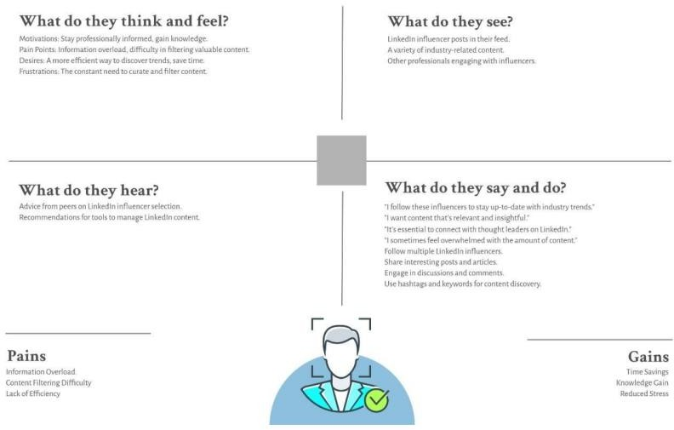

**Ideation & Brainstorming**

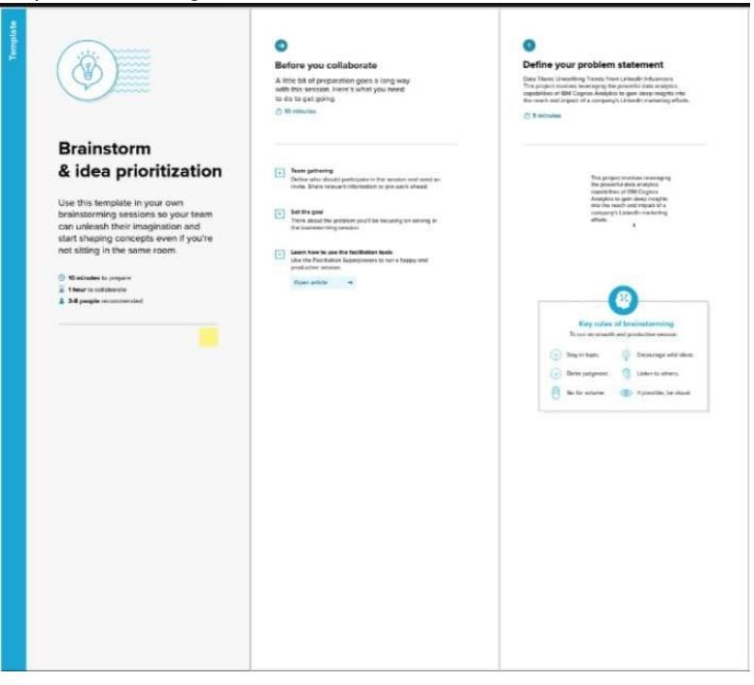

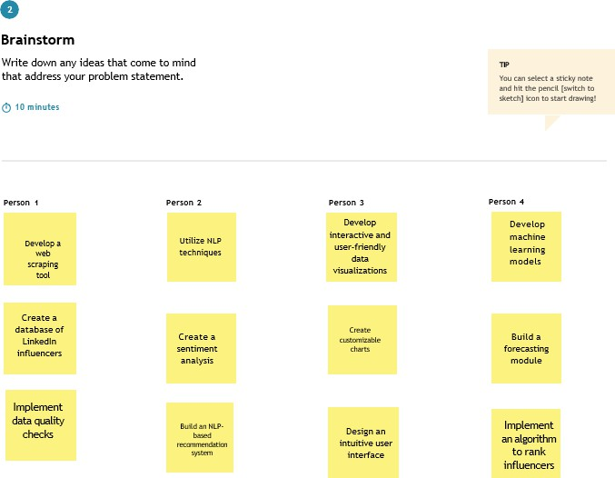

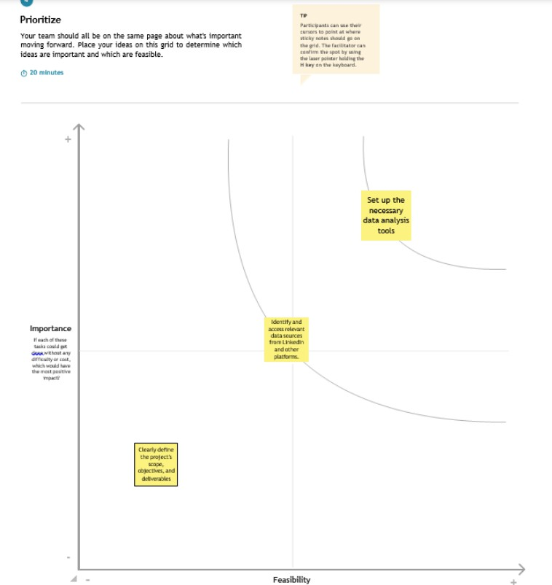

## PROPOSED SOLUTION

|  |  |  |
| --- | --- | --- |
| **S.No.** | **Parameter** |  |
| 1. | Problem Statement | An online search engine or platform that lets consumers look up and contrast costs for travel- related goods and services—like hotels, airlines, vacation rentals, and vehicle rentals—from several suppliers are referred to as a travel aggregator. In addition to offering additional amenities like reviews, ratings, and images to aid in decision-making, travel aggregators usually give customers an easy and efficient way to search for and reserve vacation-related goods and services. Expedia, Booking.com, Kayak, and Trivago are a few notable examples of travel aggregator websites. Typically, travel aggregators offer commissions or fees to the travel companies who sell the products and services that are listed on their platform in order to make money. Some make money from advertising as well as from offering other services like vehicle rentals or travel insurance.  Utilizing a travel aggregator can be an excellent method to learn regarding consumer preferences, industry trends, and the effects of outside factors. This can be accomplished through examining the travel aggregator's data, which may be used to generate insights and make data-driven decisions. This data includes bookings, reviews, prices, and other pertinent data. |

|  |  |  |
| --- | --- | --- |
| 2. | Solution description | The objective of this competitive analysis is to identify best practices and areas for improvement related to user experience and customer satisfaction among travel aggregators.  This analysis will help travel aggregators better understand their competitive landscape and make data-driven decisions to enhance their services. .  Selection of Competitors: Identify a set of key competitors in the travel aggregator industry, including both global and regional players. . .  User Experience Evaluation: Analyze the user interface and website/app experience of each aggregator, focusing on factors such as ease of use, speed, design, and overall userfriendliness. Conduct usability testing to identify pain points in the booking process. . .  Customer Support Assessment: Evaluate the quality and responsiveness of customer support services provided by each aggregator, including live chat, phone support, and email assistance. Gather customer feedback and analyze response times and problem resolution rates. . .  Localization and Personalization: Assess how well aggregators tailor their content to different markets, including offering content in multiple languages, adapting to local customs, and presenting relevant deals and destinations based on user profiles. . .  Innovative Features: Investigate the innovative features and technologies employed by aggregators, such as AI-driven recommendations, virtual reality tours, or personalized travel itineraries. . .  Competitor Response to Customer Feedback: Analyze how competitors respond to customer feedback and reviews on various platforms. Identify areas where competitors have made improvements based on customer input. . .  Comparison of Mobile Apps: Evaluate the functionality and user experience of mobile apps offered by each aggregator, considering factors like speed, user ratings, and features. . .  Data Security and Privacy: Assess the data security measures and privacy compliance of each aggregator to ensure the protection of customer information. |

|  |  |  |
| --- | --- | --- |
| 3. | Novelty/Uniqueness | To add novelty and uniqueness to the process of unearthing trends from LinkedIn influencers, the following innovative features or approaches are incorporated. Natural Language Processing (NLP) and Sentiment Analysis**.** Utilize advanced NLP techniques to not only identify trends but also to gauge the sentiment associated with them. This can provide deeper insights into how influencers' content is received by their audience. Machine Learning for Trend Prediction**.** Implement machine learning models that predict emerging trends based on historical data. This can provide early insights into what topics are likely to become popular among LinkedIn influencers.  Network Analysis**.** Analyze the connections and interactions among LinkedIn influencers. By examining who influences whom, you can uncover hidden trends and identify thought leaders in specific niches. Content Recommendations**.** A recommendation system that suggests content or influencers to users based on their interests and past interactions. This keeps users engaged and provides a unique way to discover trends.  Real-time Trend Monitoring. Provide real-time trend monitoring and alerts so that users can stay updated with the latest trends in their industry or areas of interest. Competitor Analysis. Include a feature that allows users to compare their own influence and content trends with those of their competitors. This can offer valuable competitive insights.  Multimodal Data Analysis**.** Combined textual data with visual and audio data to uncover trends in multimedia content, such as video and audio posts.  . |
| 4. | Social impact/  Customer satisfaction | By identifying and following trends in their industry or area of interest, individuals can make informed decisions about their career, learning, and skill development. This leads to personal and professional growth. Job seekers can gain insights into the skills and trends that are in demand in their field, helping them tailor their resumes and job search strategies. Companies can use trend analysis to inform their hiring strategies, ensuring they are recruiting candidates with the right skills. LinkedIn influencers can use trend insights to create content that resonates with their audience, increasing their impact and engagement.Businesses can use trend data to shape their content marketing strategies, ensuring they are producing content that is relevant and appealing to their target audience. Trend information can help professionals identify potential collaborators or mentors in their field, leading to meaningful connections. Entrepreneurs can discover market trends and find potential partners or investors in their industry. Access to trends and relevant content motivates individuals to engage in lifelong learning and stay updated in their fields. By identifying broader industry trends, businesses can adapt to changes in the market, making them more competitive and resilient. The collective knowledge generated by understanding trends can contribute to the economic development of specific regions or sectors. Providing users with trend information tailored to their interests and needs empowers them to take control of their LinkedIn experience.Ensuring data privacy and ethical handling of user data enhances customer satisfaction and trust in the  platform. |

|  |  |  |
| --- | --- | --- |
|  |  | By encouraging users to share their insights and knowledge, the platform can foster a sense of community and collaborative  learning. |
| . |

|  |  |  |
| --- | --- | --- |
| 5. | Business/ Revenue model | Offering travel aggregators data analytics services, including data preparation, data cleaning, data analysis, and solution development, could be the business model for this solution. To enhance the travel aggregator's business performance, the solution development procedure could involve identifying key findings and formulating strategies to optimize pricing, enhance the user experience, and identify growth opportunities. There are two possible income streams for this business: project-based and subscription- based. The travel aggregator would pay a one- time fee for the consulting or data analysis services under the project-based model and a recurring fee for access under the subscription- based model. to ongoing data analytics or consulting services. Offering consulting or data analytics amenities to help a travel aggregator improve its business performance and user experience is a typical business model for assessing a travel aggregator. Project-based or subscription- based fees are the main sources of revenue, and additional services may be provided |
| 6. | Scalability of the solution | The scope and complexity of the data set, availability of technological resources, and the maximum amount of clients the service provider can handle are some examples of the factors that could affect the degree to which the travel aggregator evaluation solution is.  The solution could be made more scalable in order to serve a larger number of consumers by utilizing technology and automating some aspects of it while emphasizing on providing  high-level analysis and insights |

**REQUIREMENTANALYSIS**

### Functional Requirements:

Following are the functional requirements of the proposed solution.

|  |  |  |
| --- | --- | --- |
| **FR No.** | **Functional Requirement(Epic)** | **Sub Requirement(Story/Sub-Task)** |
| FR-1 | User Dashboard | access to a dashboard that displays trend insights, analytics, and notifications based on their preferences. The dashboard should be customizable, allowing users to choose the influencers they want to follow and the industries they are interested in.  . |
| FR-2 | Trend Alerts and Notifications | real-time notifications when new trends emerge or when selected influencers post about relevant topics. |
| FR-3 | Content Scheduling | social media managers, the system content scheduling based on trending topics and  keywords. |
| FR-4 | API Integration | API for integration with other tools and platforms, enabling developers to access real-time  trend data. |
| FR-5 | Data Processing and Analysis | identify trends, keywords, and relevant topics,sentiment analysis to understand the public perception of these trends, various data analytics  techniques. |
|  |  |  |
| FR-6 | User Management | register and log in to the system.  Different user roles (e.g., marketing manager, content creator, data analyst) should have access to relevant features. |
|  |  |  |

### Non-functional Requirements:

Following are the non-functional requirements of the proposed solution.

|  |  |  |  |  |
| --- | --- | --- | --- | --- |
| **NFRNo.** | **Non-FunctionalRequirement** | | | **Description** |
| NFR-1 | Scalability |  | | The system should be scalable to handle a growing amount of data and users. It should accommodate an increasing number of influencers and industries. |
|  | | |
|  |
| NFR-2 | Security | | | Data security is paramount. The system must ensure the privacy and security of user data and the integrity of collected data. It should comply with relevant data protection regulations. |
|  |
| NFR-3 | Usability | | | The user interface should be intuitive and user-friendly, catering to users with various levels of technical expertise. Accessibility considerations should be taken into account. |
|  |
| NFR-4 | Performance | | | The system should provide quick and responsive performance in terms of data retrieval, analysis, and notifications. It should handle concurrent user requests efficiently. |
|  |
| NFR-5 | Maintenance and Support | |  | The system should have a plan for regular maintenance, updates, and technical support for users. |
|  | | |

## PROJECT DESIGN

**Data Flow Diagrams**:

A Data Flow Diagram (DFD) is a traditional visual representation of the information flows withinasystem.AneatandclearDFDcandepicttherightamountofthesystemrequirementgraphically.It shows how data enters and leaves the system, what changes the information, and where data isstored.

**DFDLEVEL0:**

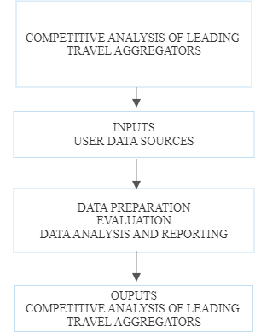

**DFDLEVEL1:|**

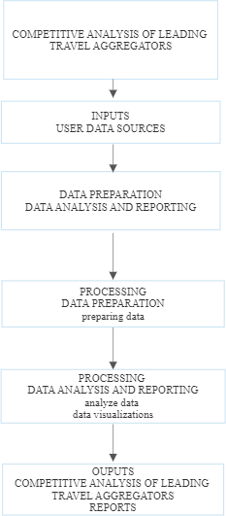

## DFD LEVEL 2 :

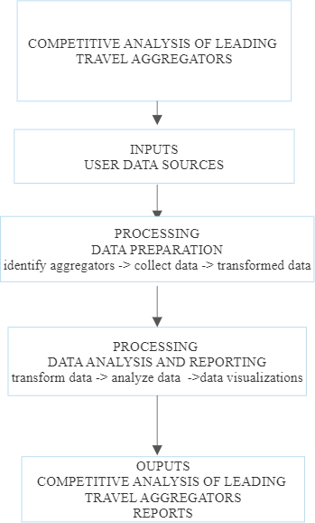

**SOLUTION AND TECHNICAL ARCHITECTURE:**

Creating a solution architecture for the competitive analysis of Unearthing trends from linkedin influencers involves designing a structured framework that outlines the components, technologies, and processes required to collect, analyze, and present the data and insights.

Here's an overview of the key components of a solution architecture for this purpose: Competitor Selection-Define a list of leading linkedin influencers to analyze.



Data Sources-Identify sources of data for competitive analysis, such as websites, mobile apps, APIs, social media, and third-party data providers.

Data Warehouse- Set up a data warehouse for storing historical and real-time data for analysis.



Data Security- Implement robust security measures to protect sensitive data and ensure compliance with data privacy regulations.

Backup and Recovery- Implement a robust disaster recovery plan and ensure data redundancy to prevent data loss in case of system failures.

Regular Maintenance- Schedule routine maintenance to ensure the solution's smooth operation and to address any issues that may arise.

Updates and Upgrades- Keep software and technologies up to date to take advantage of the latest features and security

## TECHNICAL ARCHITECTURE:

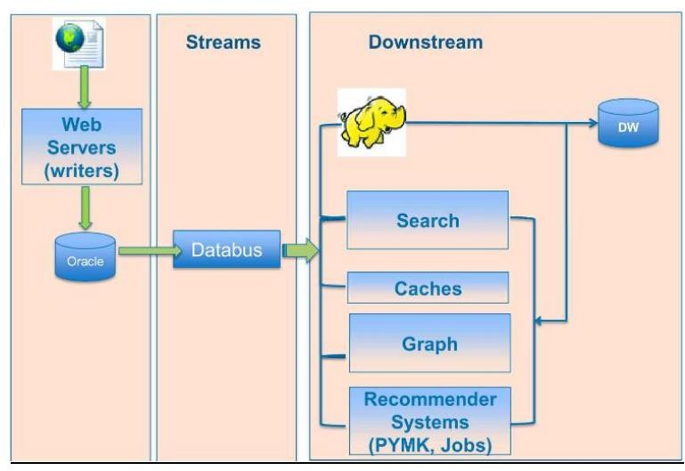

**Table-1:Components &Technologies:**

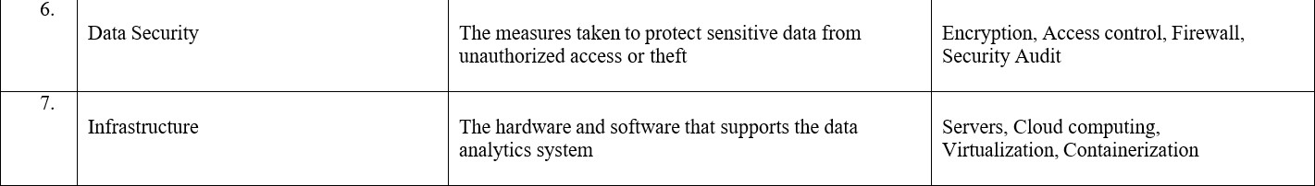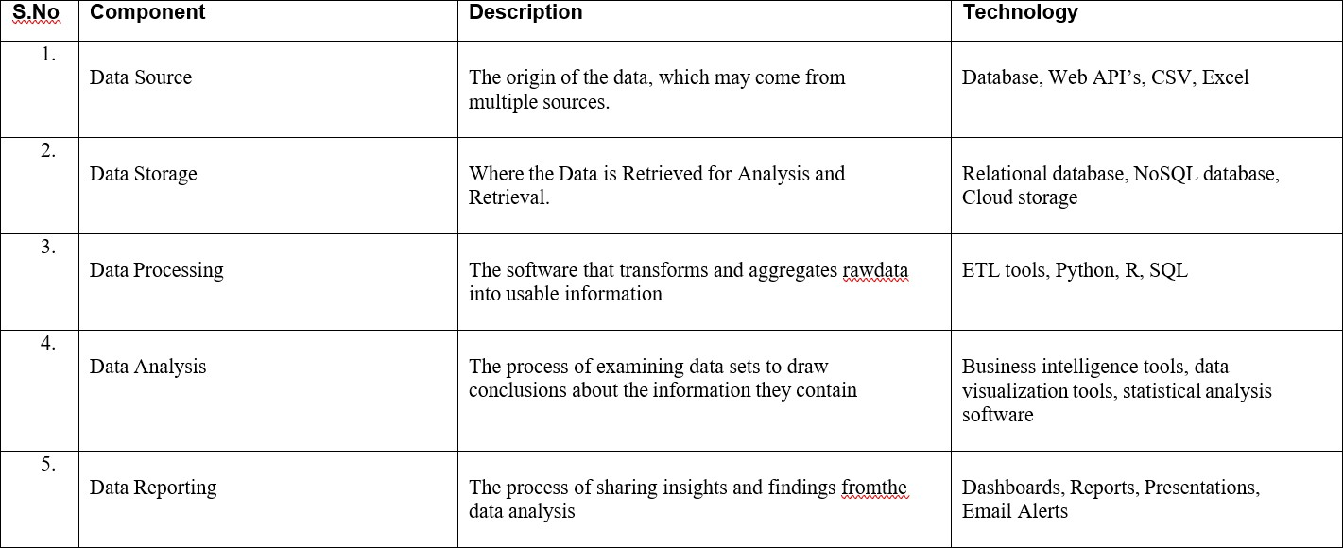

**Table-2:ApplicationCharacteristics:**

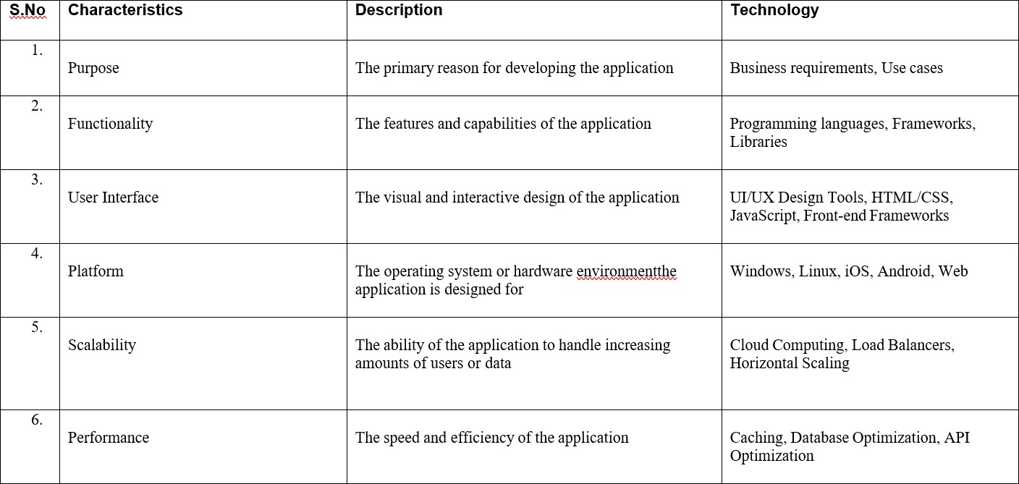

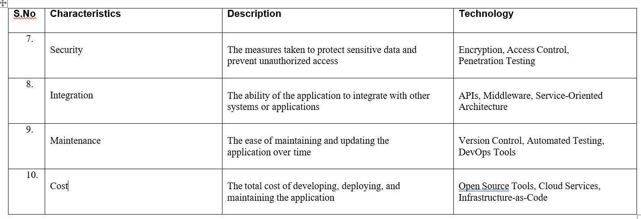

## PROJECT PLANNING & SCHEDULING

**User Stories**

|  |  |  |  |  |  |  |
| --- | --- | --- | --- | --- | --- | --- |
| **USER TYPE** | **FUNCTIONAL REQUIREMENT** | **USER STORY NUMBER** | **USER STORY/TASK** | **ACCEPTANCECRITERIA** | **PRIORITY** | **TEAM MEMBER** |
| LinkedIn influencer s  Timeline and analyser | Search functionality  Review  and Timeline | US001  US002 | Clearly outline the goals, objectives, and deliverables of your project. What specific trends are you looking to unearth, and how will you measure success?  Regularly review the project’s  progress, adapt the schedule as needed, and refine your data collection and analysis methods. | Identify Key LinkedIn Influencers: Select the influencers in your industry or niche whose insights and content are relevant to your project.  Data Collection and Analysis: Decide on the data sources, such as their LinkedIn posts, articles, or comments, and develop a strategy for data collection. Consider using web scraping tools or APIs.  1.Data Analysis Tools: Select the tools and software you'll use for data analysis. Popular choices include Python libraries (e.g., NLTK, spaCy) and data analytics platforms (e.g., Tableau).  Timeline and Milestones: Create a project timeline with clear milestones. Consider how often you'll collect data, analyze trends, and report findings. | High  High | Gopinath,  aathif  Rajesh,  Aathif  Pavithra ,  Rajesh  Gopinath,  Pavithra |

**CODING AND SOLUTION:**

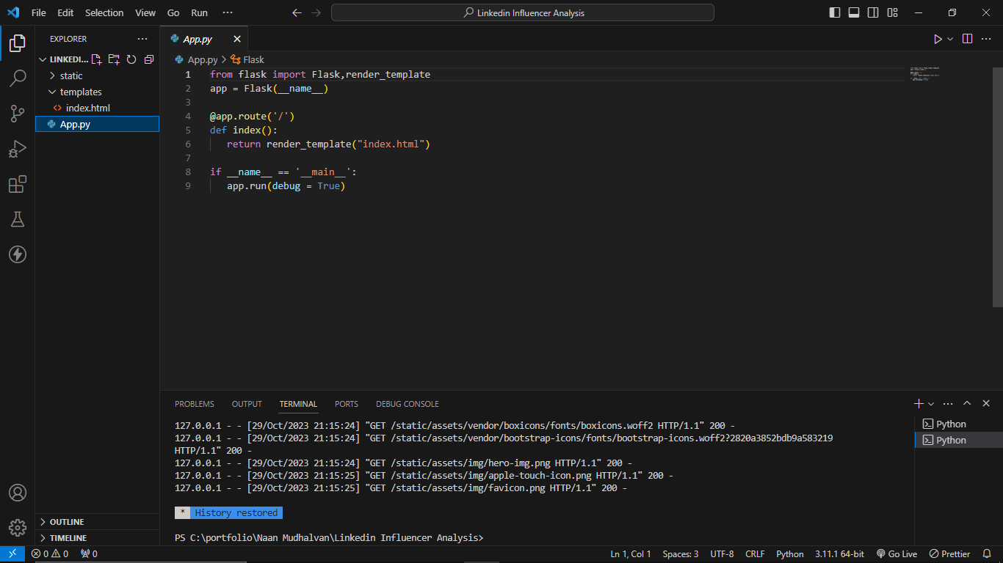

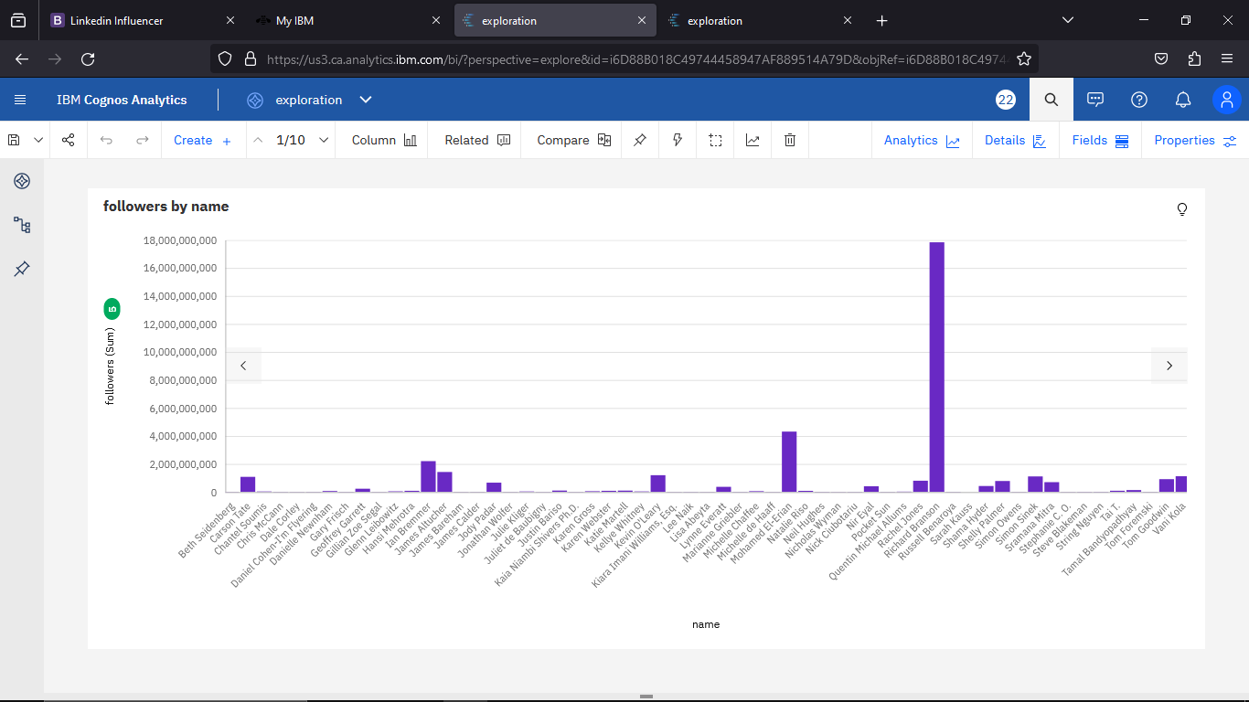**OUTPUT:**

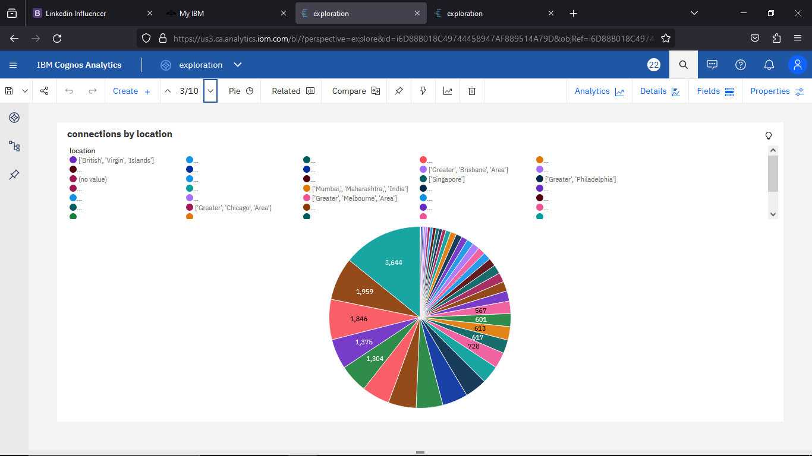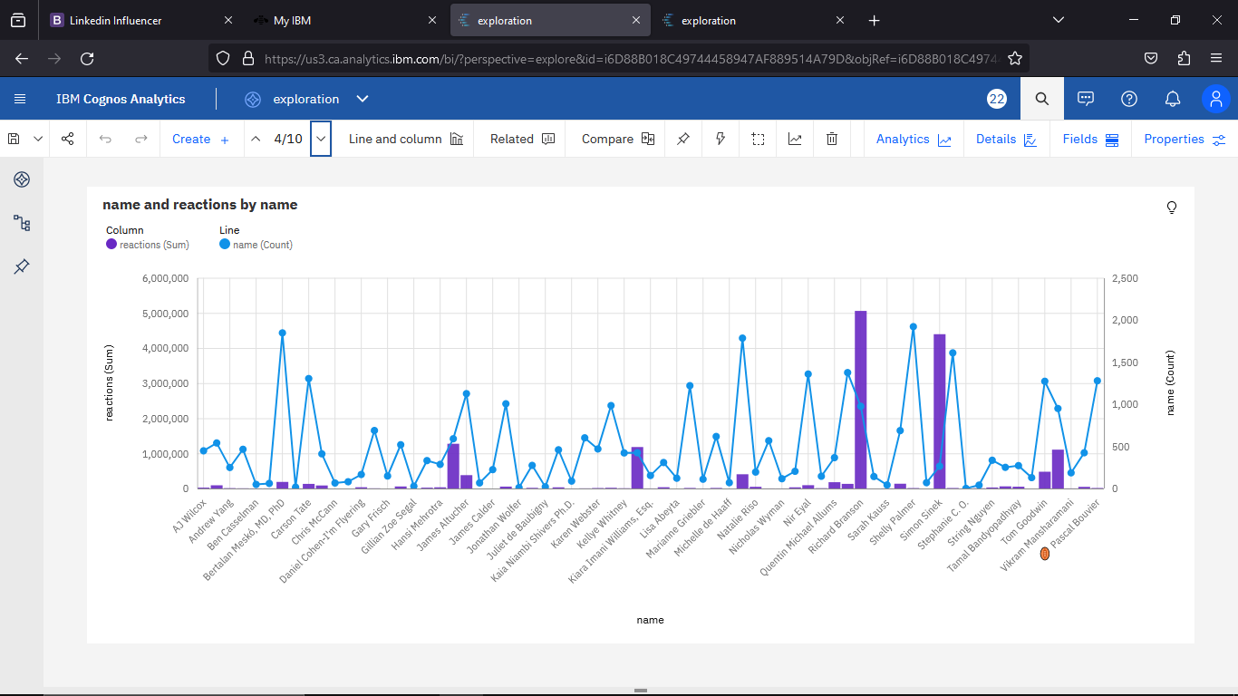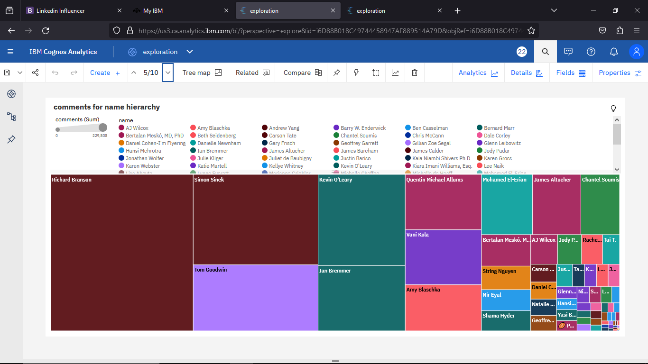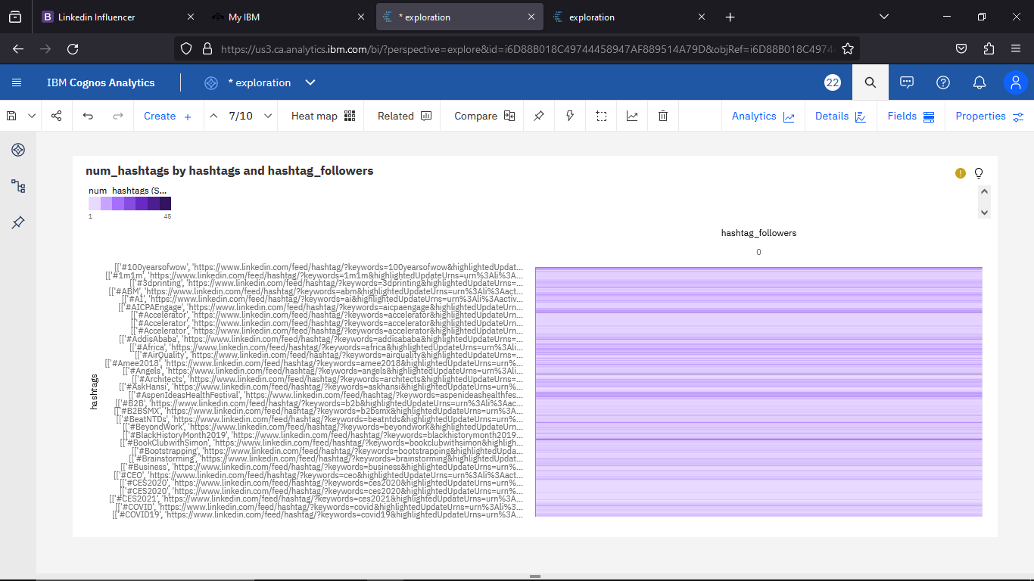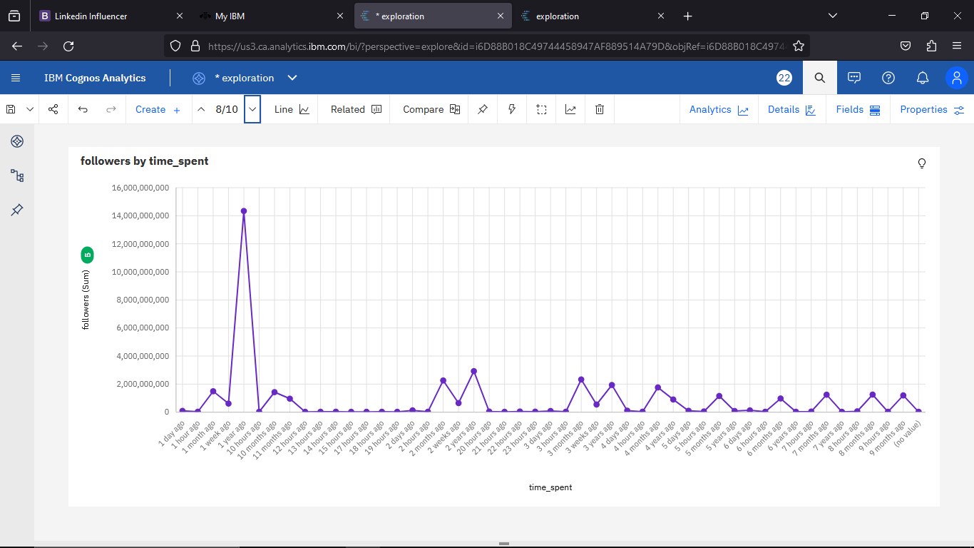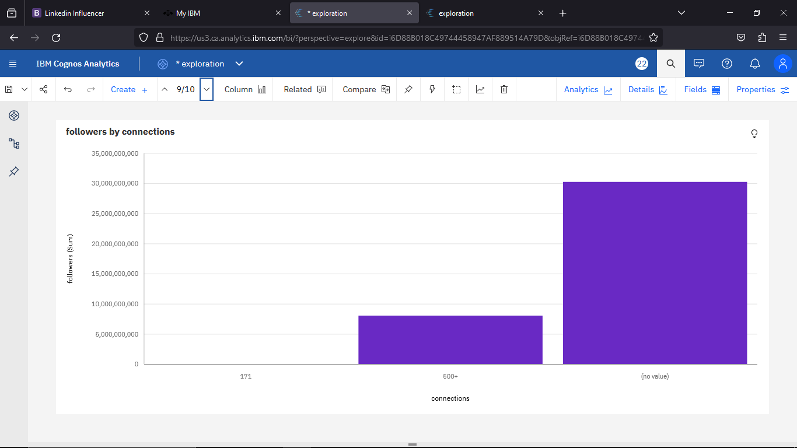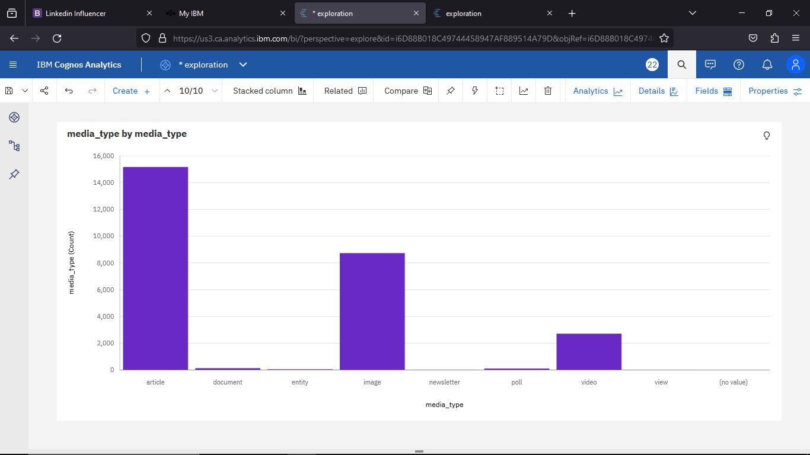

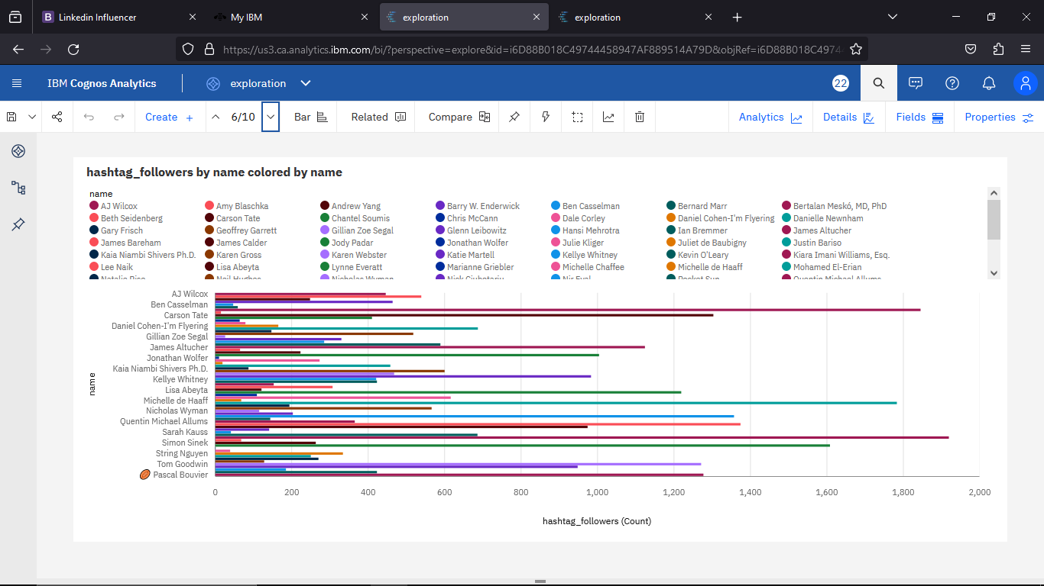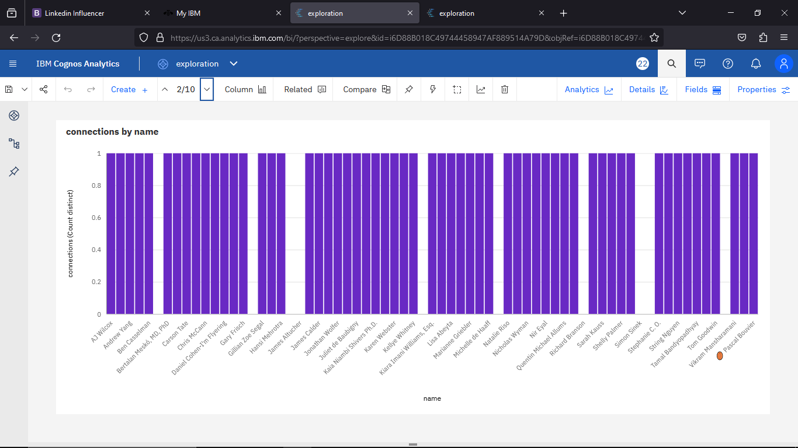

**HOMEPAGE:**

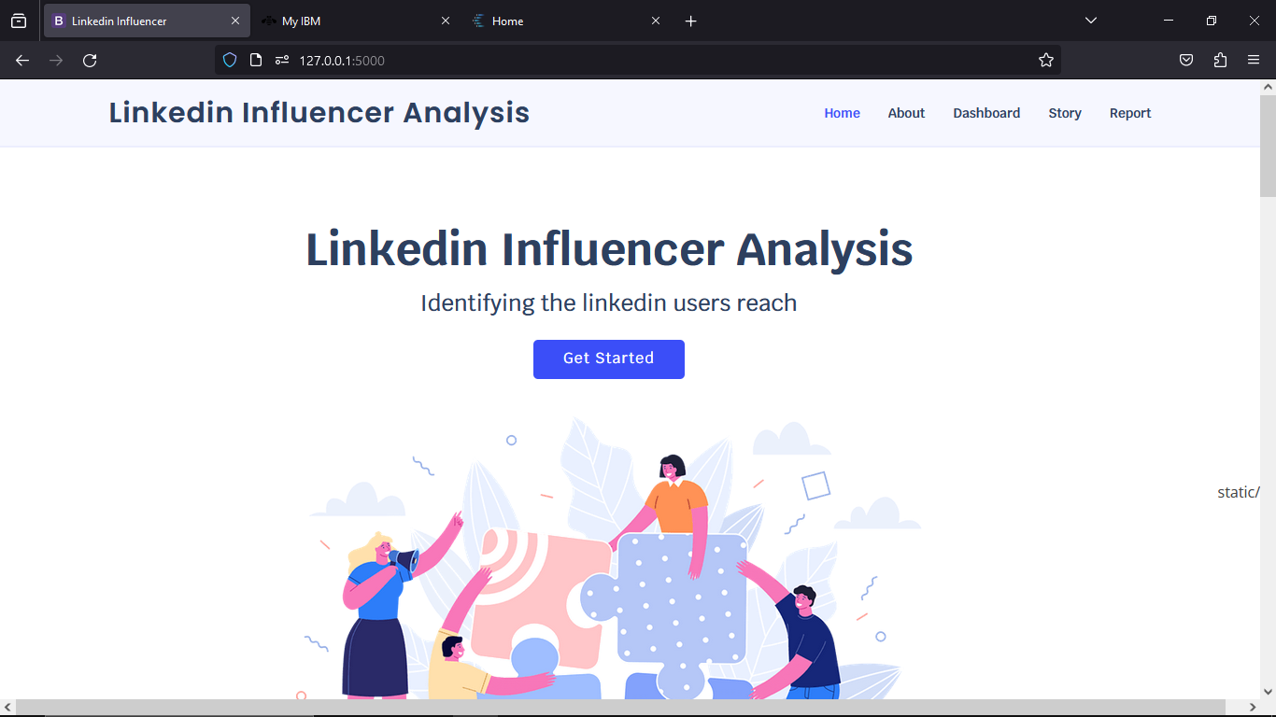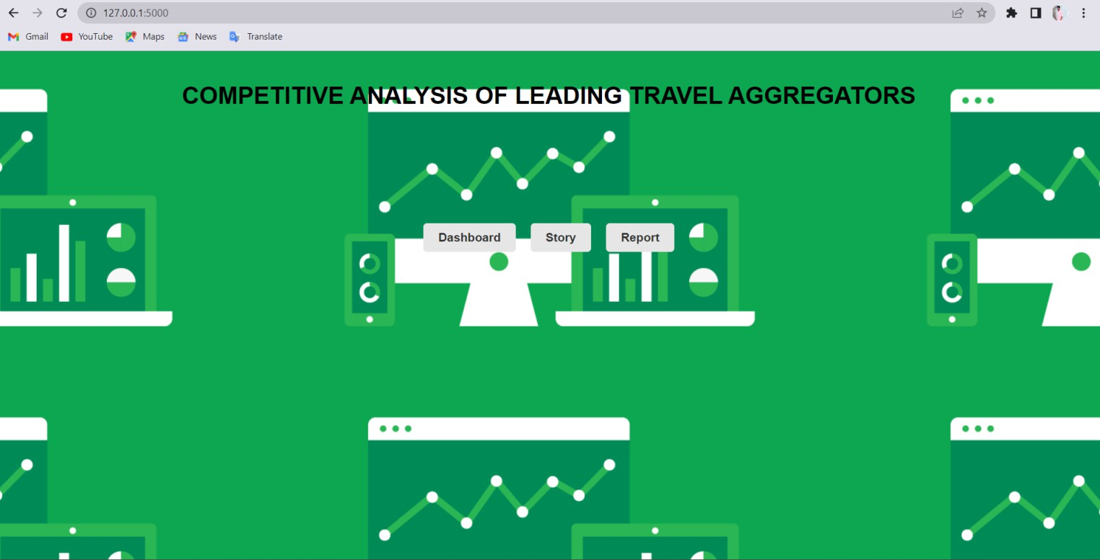

**DASHBOARD:**

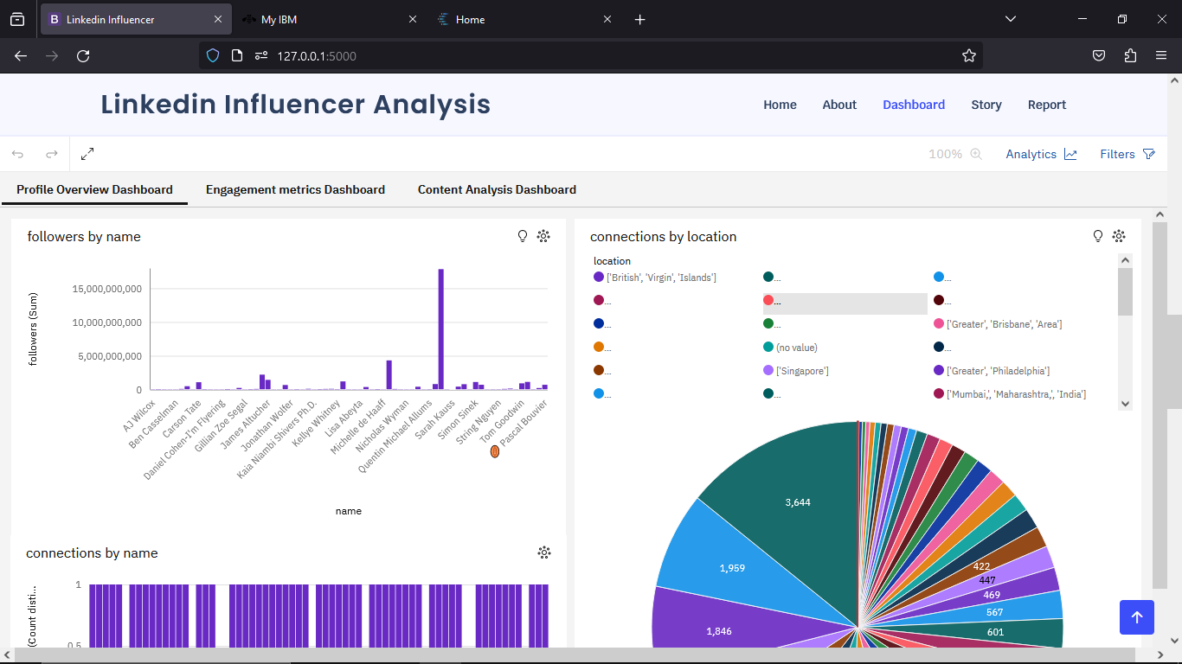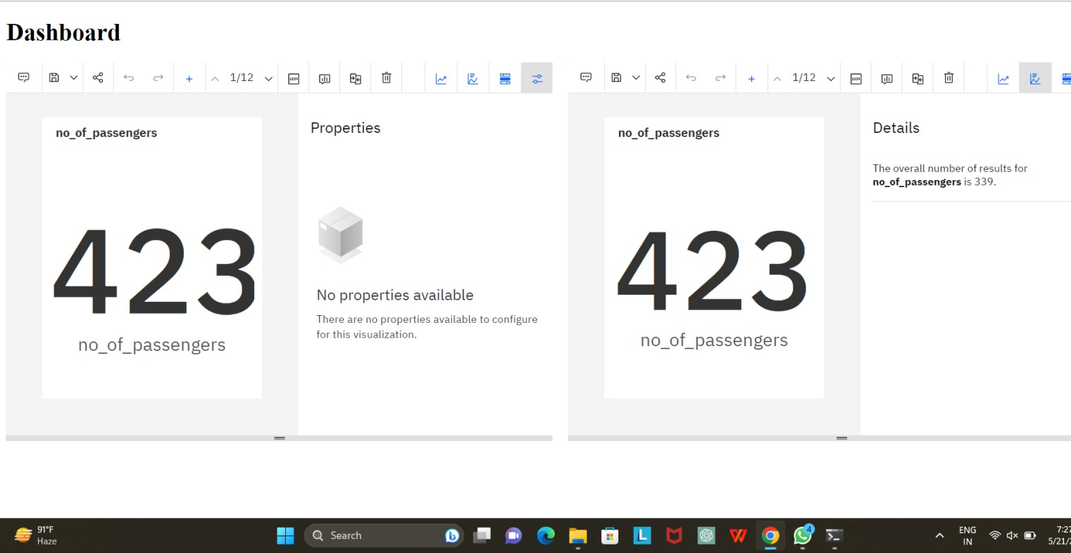

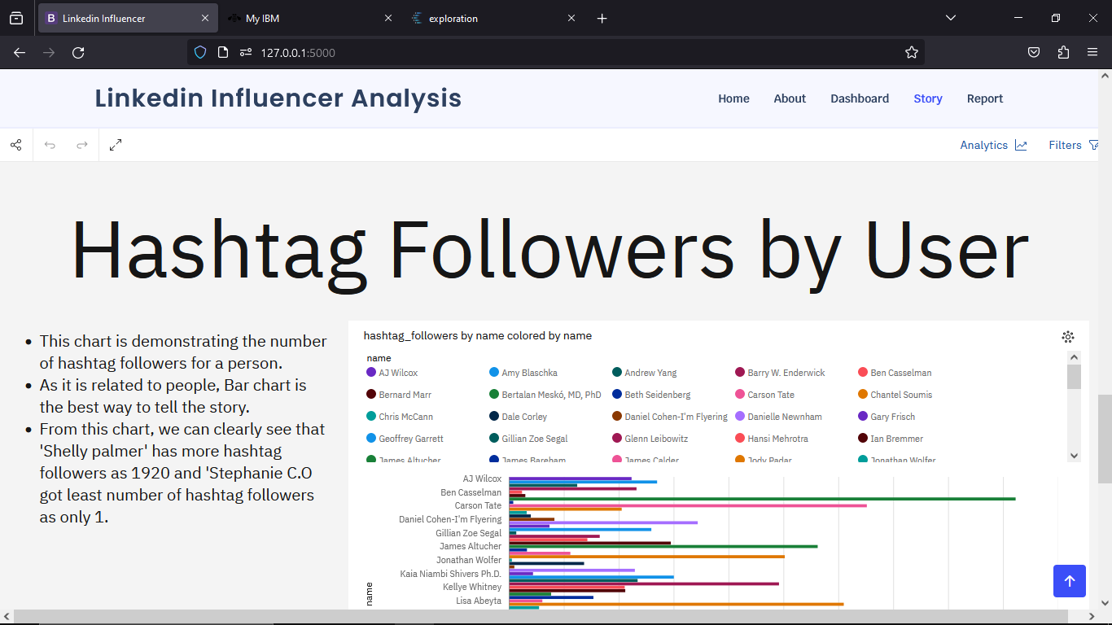**STORY:** 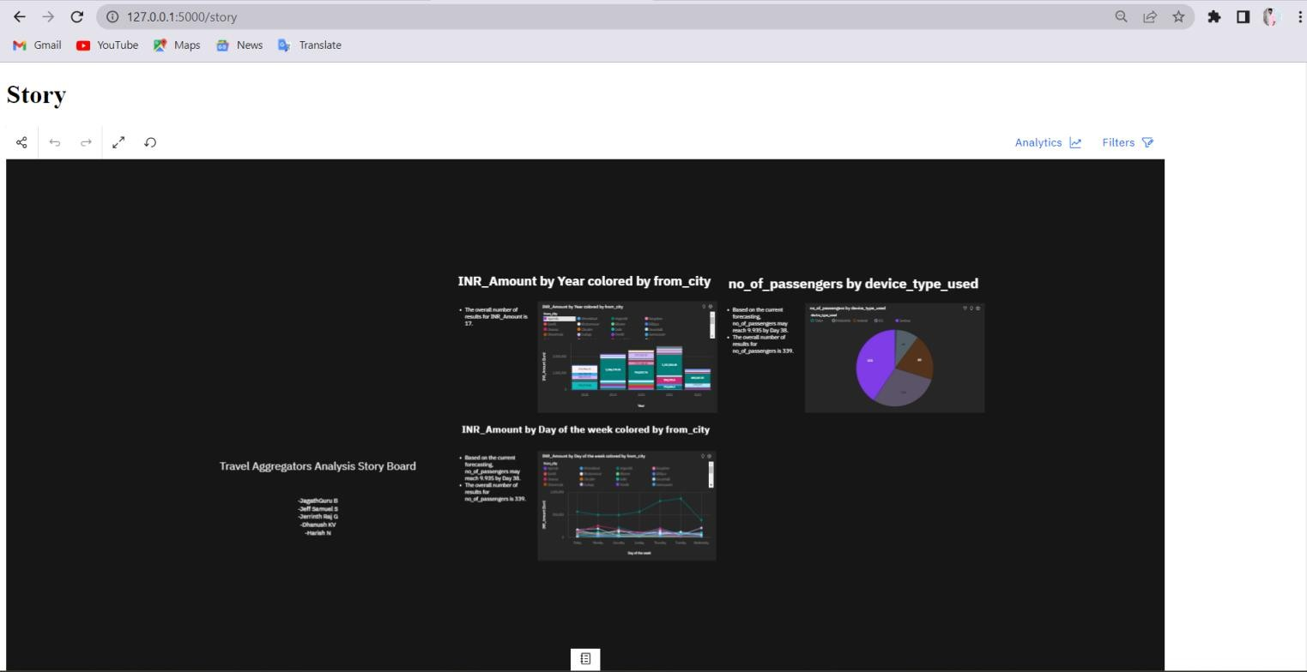

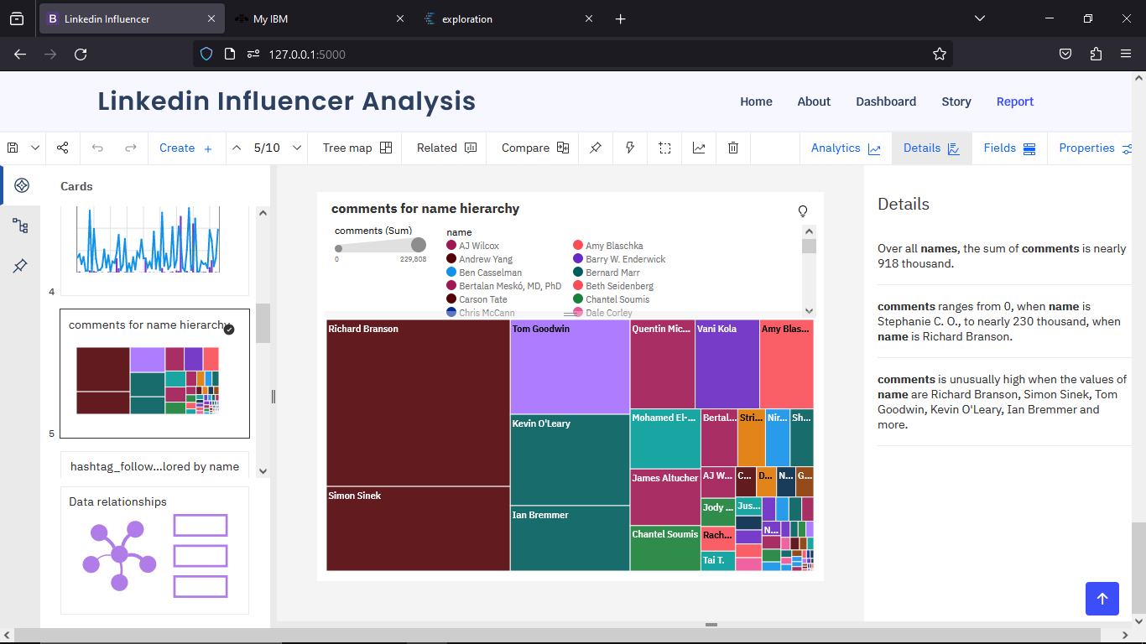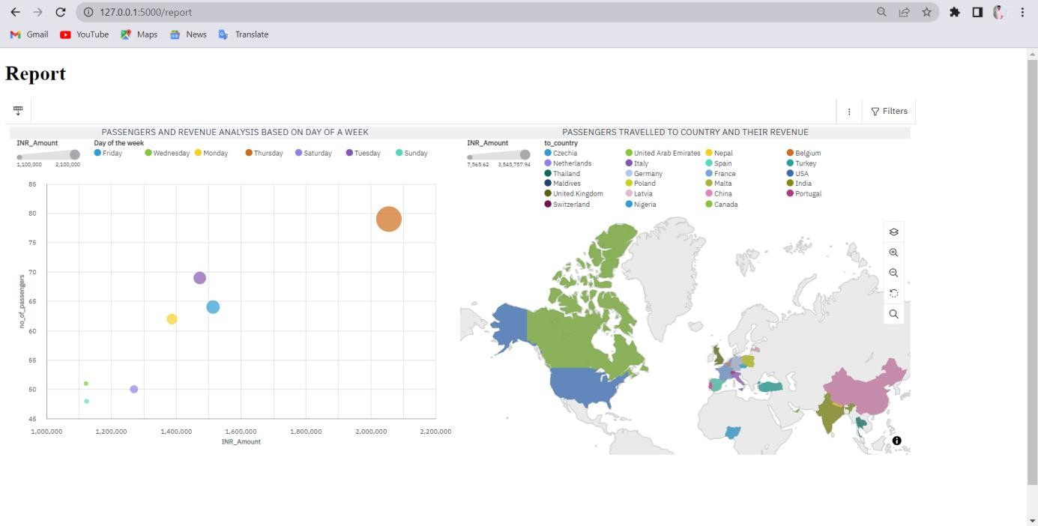**REPORT:**

**TESTING:**

**TEST CASES:**

Creating test cases for a travel aggregator analysis project is crucial to ensure that the system functions correctly and meets its requirements. Here are some sample test cases that you can consider for such a project:

1. **Aggregation Accuracy Comparison**: Compare the results of your analysis with data from multiple reputable sources, such as individual travel websites or official tourism boards. Verify if the aggregated information, including prices, availability, and destination details, aligns with data from these sources.
2. **Price Comparison**: Choose a popular destination and compare prices for flights, accommodations, and car rentals from various travel aggregators. Ensure that the analysis effectively captures and presents the best deals, discounts, and price variations across different platforms.
3. **Destination Coverage Assessment**: Test the analysis's ability to encompass a wide array of destinations. Confirm that it covers both well-known tourist spots and more obscure, offbeat locations. Compare the results with established travel destinations to validate the analysis's comprehensiveness.
4. **Travel Package Analysis**: Evaluate the analysis's capacity to aggregate and compare complete travel packages, which include flights, accommodations, and activities. Ensure that it offers diverse options and accurately displays package prices, inclusions, and availability.
5. **Real-Time Updates Test**:Conduct a test to measure how quickly the analysis updates its data in response to fluctuations in prices, availability, or other pertinent information. Observe the analysis over a specified time frame and compare the results with real-time updates from individual travel websites.
6. **User Experience Evaluation**: Assess the usability and user interface of the travel aggregation analysis. Evaluate its ease of navigation, search features, filters, and sorting capabilities. Confirm that users can easily access the desired information and efficiently compare various travel options.
7. **Data Integrity Check**: Execute a test to ensure that the analysis doesn't present outdated or erroneous information. Confirm that the data, such as prices, availability, and reviews, is current and accurate.

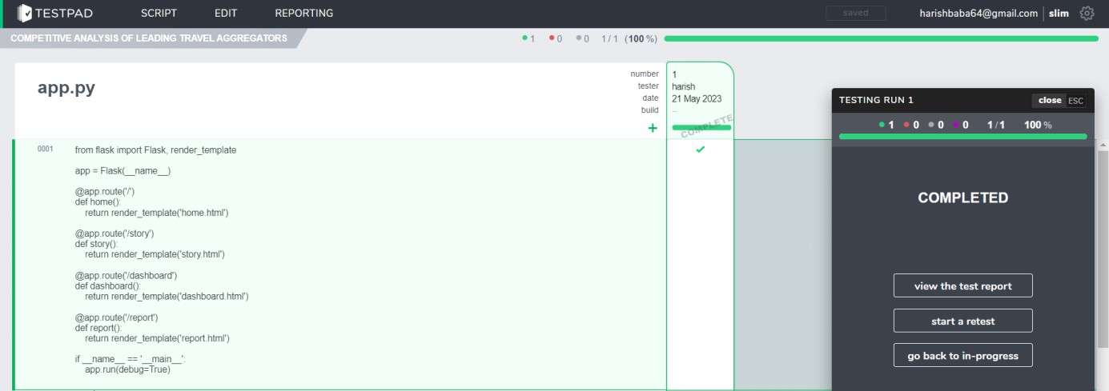

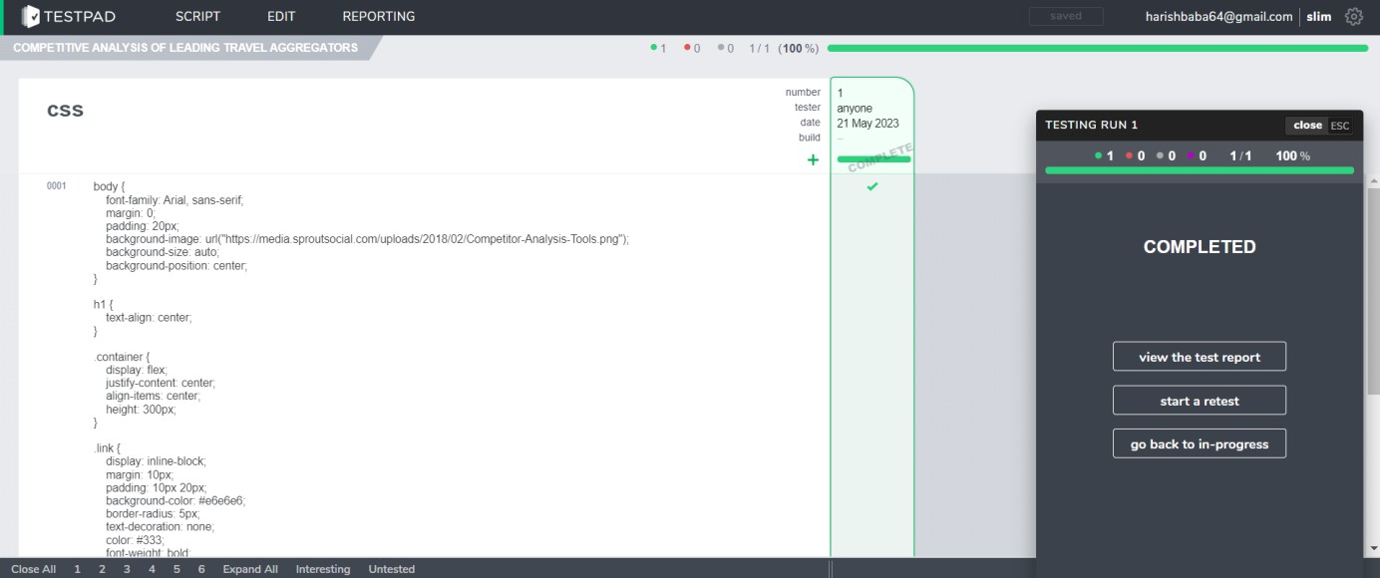

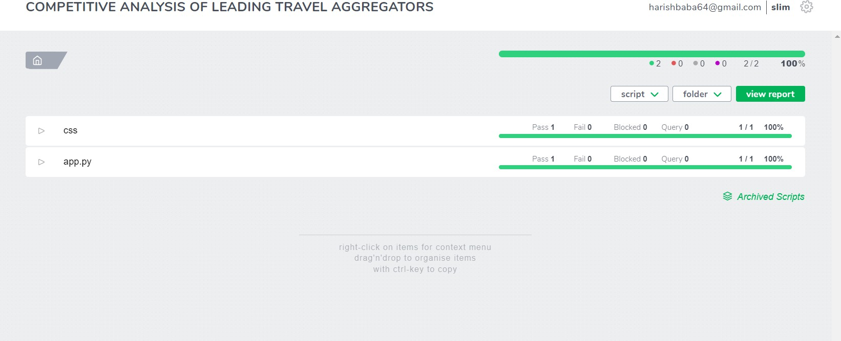

## PERFORMANCE METRICS:

**ADVANTAGES & DISADVANTAGES:**

### Advantages of LinkedIn influencers:

1. Valuable Insights: LinkedIn influencers often have unique perspectives and insights in their respective fields.
2. Identifying trends from their content can provide valuable information that can inform decision-making.
3. Competitive Intelligence: Understanding what influencers are discussing and advocating for can help your organization stay competitive by staying ahead of industry trends and changes.
4. Thought Leadership: Utilizing insights from LinkedIn influencers can help position your organization as a thought leader by engaging with current, relevant topics in your industry.
5. Networking Opportunities: Engaging with influencers and their content can create networking opportunities and potential collaborations with key figures in your industry.
6. Data-Driven Decision-Making: The project allows for data-driven decision-making, based on trends and patterns observed in the content of influencers, rather than relying solely on intuition or guesswork.
7. Content Strategy Enhancement: Unearthing trends from influencers can inform and improve your content strategy, helping you create content that resonates with your target audience.
8. Improved Marketing ROI: Targeted marketing and content strategies can lead to improved return on investment (ROI) as you focus your efforts on what’s most relevant and valuable to your audience.
9. Brand Reputation Management: Monitoring influencer content can help you manage your brand’s reputation by addressing issues or concerns raised by influential figures in your industry

### Disadvantages of LinkedIn Influencers :

1. Data Privacy Concerns: Collecting data from LinkedIn and influencers’ profiles may raise privacy issues and could potentially lead to ethical concerns, especially if not done in compliance with platform policies.
2. Data Accuracy: The quality and accuracy of the data collected may vary, which can lead to biased or unreliable insights. It’s crucial to ensure data integrity and quality control.
3. Resource Intensive: Data collection, processing, and analysis can be resource-intensive, requiring time, personnel, and potentially specialized tools or software.
4. Platform Policy Changes: LinkedIn’s policies and algorithms may change over time, affecting your data collection methods and making it necessary to adapt your project.
5. Limited Access: Not all influencers’ content may be publicly accessible, limiting the scope of your data collection and analysis.
6. Oversaturation of Data: The sheer volume of content from influencers can be overwhelming, making it challenging to sift through and identify meaningful trends.
7. Interpretation Bias: The interpretation of trends can be subjective, potentially leading to bias in the analysis and decision-making process.
8. Influencer Reliability: Not all influencers are equally credible, and some may promote controversial or misleading content, which could negatively impact your project’s findings.
9. Changing Trends: Trends evolve rapidly, and what is trending today may not be relevant in the near future. Keeping up with changing trends can be demanding.
10. Competitive Advantage Erosion: If your competitors also have access to the same influencers’ content, it may reduce the competitive advantage gained from this project.

## CONCLUSION:

In conclusion, the project of unearthing trends from LinkedIn influencers offers significant advantages in terms of gaining valuable insights, competitive intelligence, targeted marketing, thought leadership, and data-driven decision-making. However, it is not without its disadvantages, including potential data privacy concerns, data accuracy issues, resource intensity, and the need to navigate platform policy changes.

To make this project successful, it is essential to address these challenges proactively and maintain a strong commitment to data quality, ethical data collection practices, and a clear

Understanding of the ever-evolving nature of trends in the digital landscape.

Ultimately, the success of this project hinges on the ability to transform influencer-generated content into actionable insights that drive informed decision-making, foster innovation, and enhance your organization’s presence and competitiveness within your industry. It’s important to continually adapt to changes in the influencer landscape and to assess the project’s ROI to ensure its long-term value to your organization.

## FUTURE SCOPE:

The future scope of a project focused on unearthing trends from LinkedIn influencers is promising, considering the evolving digital landscape and the increasing significance of influencer marketing. Here are some potential future directions and opportunities:

1. Advanced Data Analytics: As data analytics technologies continue to advance, the project can leverage more sophisticated tools for trend analysis, including machine learning, deep learning, and predictive analytics.
2. Real-Time Monitoring: Implementing real-time trend monitoring can provide immediate insights, allowing organizations to respond quickly to emerging trends and topics.
3. Cross-Platform Analysis: Expanding beyond LinkedIn to include other social media platforms and digital channels can provide a more comprehensive view of trends in the industry.
4. Natural Language Processing (NLP): NLP algorithms can be used to understand the sentiment and context of influencer content, providing deeper insights into trends.
5. Personalized Content Recommendations: Based on the trends identified, the project can work on delivering personalized content recommendations to users, increasing engagement and relevance.
6. Influencer Collaboration: The project can evolve to involve collaboration with influencers directly, potentially creating partnerships to co-create content and explore trends together.
7. Visual and Multimedia Trends: Expanding the project to analyze visual and multimedia content, such as images and videos, which are becoming increasingly important in online marketing.
8. Blockchain and Data Security: Implementing blockchain technology for data security and transparency, ensuring compliance with privacy regulations.
9. Ethical AI: Focusing on the ethical use of AI and data, addressing concerns related to data privacy and bias.
10. Market Segmentation: Using trends to identify and understand specific market segments and tailor strategies for each.

## APPENDIX :

**GITHUB:**

https://github.com/GopI-2026/naan-mudhalvan

## PROJECT DEMO LINK:

https://drive.google.com/file/d/13PanQITDd3KB1SfVRjJ3Dg5u2a7MRtE2/view?usp=drive_link